

**4-Story Elevator**

**Supervisor: Dr. Belal Sababha**

|  |  |
| --- | --- |
| **Name** | **ID** |
| Lunar Salameh | 20190983 |
| Mohannad Oweis | 20190583 |
| Khaled Abu Rubaia | 20190833 |

**Abstract**

Embedded systems have gained significant importance in modern technology, finding applications in various industries. One such application is the use of elevators, which have become ubiquitous due to their effectiveness and ease of use. This project proposes and implements a mini-4-story elevator using an embedded system approach.

Table of Contents

1. Introduction 3

2. Design 3

2.1 Mechanical Design 3

2.2 Electrical Design 5

2.3 Software Design 6

3. Problems and recommendations 7

4. Conclusion 7

# 1. Introduction

Embedded system has become an integral part of modern technology, with a wide range of applications in various industries, one of which is using Elevators as it has become one of the main systems used everywhere due to its effectivity and easy and comforting functionality.

Which gave us the idea to propose and implement a mini-4- story elevator. This embedded system will be utilized using PIC16F877A microcontroller, it will also contain an Ultra-Sonic Sensor, 7 segment display to display, DC motor, DC motor driver (L298N), Two led lights (Green and Red), lastly is 4 buttons in which every button will be used to request a specific floor to go to.

# 2. Design

The design of this Embedded system project is a 4-Story elevator. This Elevator will be utilized using PIC16F877A microcontroller, which will be implemented to control the movement and the speed of the elevator upward and downward, knowing that the elevators speed will change depending on if it is close to the requested floor, it will slow down if not it will continue in its given speed which is implemented using PWM technique knowing that its initial speed depends on how many floors the elevator needs to move.

Our design will also contain an Ultra-Sonic Sensor to be able to determine where the elevator is currently in, 7 segment display to display where the elevator is located and show the changes during the movement of the elevator, DC motor and its driver to be able to move the elevator based on the implementation of the MCU, the Red light will turn on when the Elevator is moving and the Green light when it is idle, lastly is 4 buttons in which every button will be used to request a specific floor to go to, in the following figures you will be able to see each of the Mechanical, Electrical and Software Design of out embedded system design:

## 2.1 Mechanical Design

In the mechanical design of the elevator includes two foam boards, one will be used as the ground of the elevator and the other one will be used as the wall of it in which it will provide support for the other components, Two 3D printed pieces which holds in between two metal columns, with another piece that is also 3D printed has two holes that the metal will go through them, then we added a box made from light wood as the elevator to the 3D printed piece.

After that we brought one rode which is connected to two pulleys one of them is up and the other one is down connected to the DC Motor so that it can move the elevator up and down easily. lastly, we added Two lights Green when its idle and Red when its moving.

The components:

|  |  |
| --- | --- |
| * C:\Users\LENOVO\Desktop\Embaded\PIC.jpgPIC16F877A | * Ultra-Sonic |
| * DC Motor | * DC Motor Driver (L298N) |
| * Bushed Buttons | * 7 segment Display |
| * Led Lights |

You can see the Design in the Following Figure:

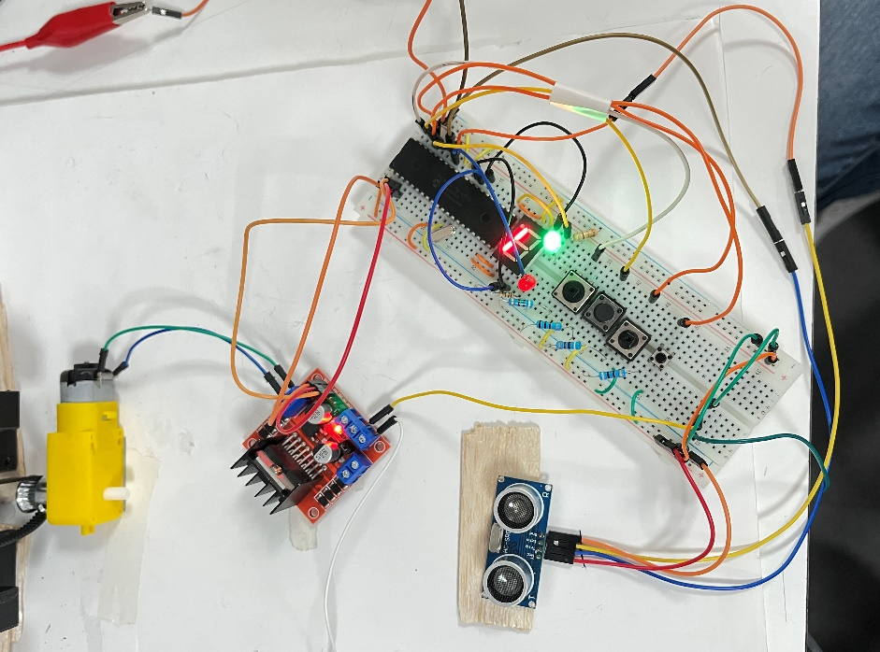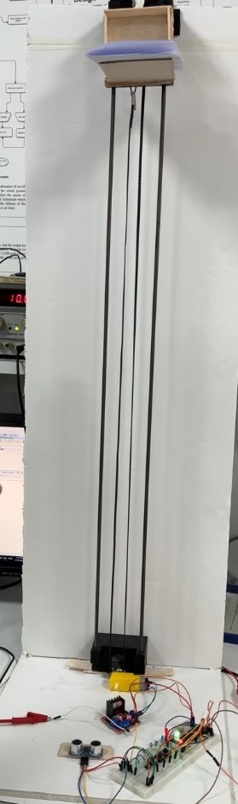

Figure : Mechanical Design of The Elevator

## 2.2 Electrical Design

Using Proteus software we have designed the electrical design of our Elevator, which gives a clear look into how we connected all of our components together. 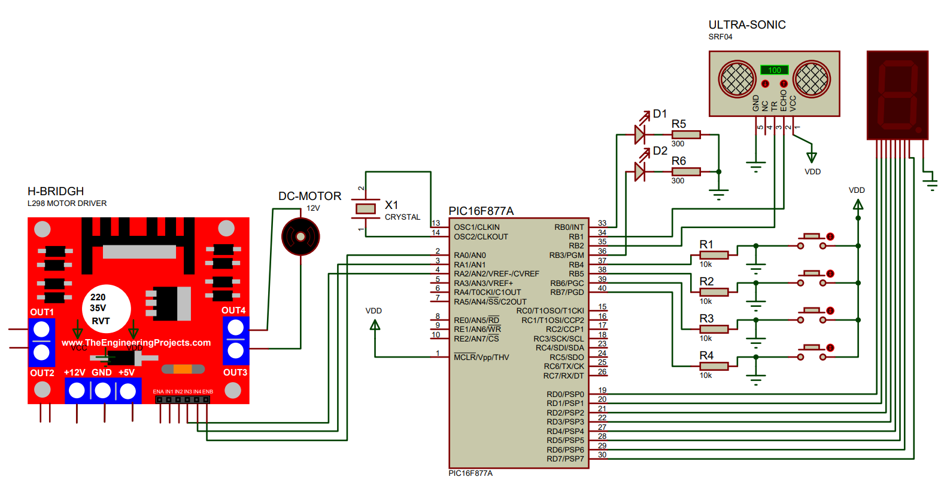

Figure : Electrical Design of the Elevator

## 2.3 Software Design

The following Software design shows the functionality of the Elevator.

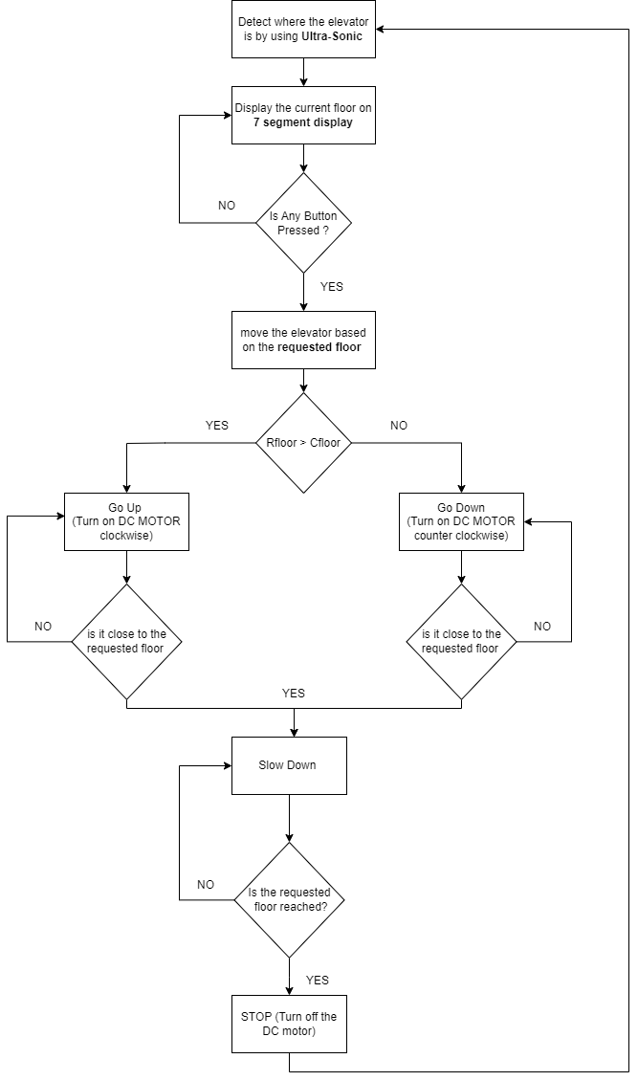

Figure : Flow chart

# 3. Problems and recommendations

Some of the problems that we have encountered during our implementation of the elevator is:

1. We had a problem in our code implementation where the elevator had floor #1 in two different destinations.  
   **Solved** by changing the calculations we had.
2. Problem with the ultra-sonic, where it wasn’t reading the distance correctly.  
   **Solved** by us learning that the ultra-sonic reads the distance in a degree of 30o which helped us on how to deal with it and design our elevator accordingly.
3. Connecting the Elevator with Two rods   
   **Solved** by connecting it with one rode.

# 4. Conclusion

In conclusion, the implementation of the mini-4-story elevator embedded system project was a challenging yet successful endeavor. Despite encountering various problems during the development process, such as code implementation issues and difficulties with the ultrasonic sensor and elevator connections, solutions were found to overcome these obstacles. The result is an effective elevator system that seamlessly moves between floors, adjusting its speed when approaching the desired destination. This project demonstrates the feasibility and functionality of embedded systems in creating reliable and user-friendly elevator solutions.